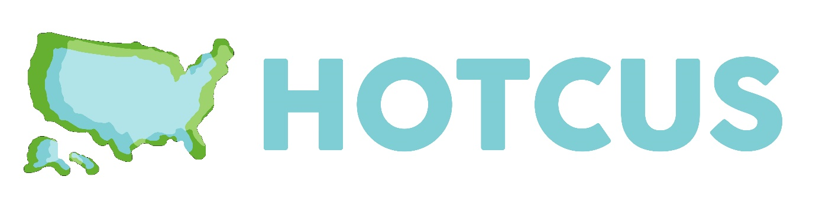
2025 HOTCUS Committee Nomination Form
Please complete this nomination form and email it to Miguel Hernandez (mih72@aber.ac.uk) by the deadline of 5:00pm, Friday 16 May 2025.
Please also include a recent photograph to include on the HOTCUS online election announcement.
Name
Email address
Institution
Position sought
Seconder’s name
Seconder’s email address
Seconder’s institution
Statement of intent (no more than 250 words)

